A MAJOR-PROJECT REPORT

ON

***“BILL PAYMENT SYSTEM”***

Submitted to :

JAYPEE INSTITUTE OF INFORMATION TECHNOLOGY

BY

SAURABH KUMAR SINGH(15102128)

JAYPEE INSTITUTE OF INFORMATION TECHNOLOGY

Sec-62, Noida, U P

2018-2019

|  |  |  |
| --- | --- | --- |
|  | | |
|  | | |
|  | | |
|  | | | |
|  | | | |
| **CERTIFICATE**  This is to certify that the project report titled **“**BILL PAYMENT SYSTEM**”** by Saurabh Kumar Singh in partial fulfilment of the requirements for the award of the Degree of Bachelor of Technologyin Electronics and Communication Engineering is a bonafide record of the work carried out under our guidance and supervision at, Cognizant Technology Solutions, Pune. | | | |
|  |  |

|  |  |  |
| --- | --- | --- |
|  | **Signature and Seal of Training Manager**  **Signature of the Supervisor**  **Mrs. Ashu Jauhari** | |
|  | |  |

**ACKNOWLEDGEMENT**

We feel immense pleasure and feel privileged in expressing our deepest and most sincere gratitude to our supervisor Mrs**.** AshuJauhari, for her excellent guidance throughout our project work. Her kindness, dedication, hard work and attention to detail have been a great inspiration to us. Our heartfelt thanks to you ma’am for the unlimited support and patience shown to us. We would particularly like to thank her for all her help in patiently and carefully correcting all our manuscripts. We acknowledge the support received from Cognizant Technology Solutions, Pune. We are also very thankful to our B.Tech Major Project coordinators Dr Archana Pandey and Mrs. Shradha Saxena(Major Project Coordinators) and also Mr. Kapil Sud (T&P Head) for their support and suggestions during our course of the project work in the final year of our undergraduate course.

**SAURABH KUMAR SINGH (15102128)**

ABSTRACT

**Cognizant** is an American multinational corporation that provides IT services, including digital, technology, consulting, and operations services. It is headquartered in Teaneck, New Jersey, United States of America. Cognizant is included in the NASDAQ-100 and the S&P 500 indices. It is also one of the fastest growing Fortune 500 companies. It was founded as an in-house technology unit of DUN & BRADSTREEIN in 1994, and started serving external clients in 1996.

Cognizant had a period of fast growth during the 2000s, becoming a Fortune 500 company in 2011. In 2015, the FORTUNE Magazine named it as the world's fourth most admired IT Services company. In 2017, Cognizant was named in Fortune’s Future 50 list.

Cognizant provides information technology, information security, consulting, ITO and BPO services. These include business & technology consulting, system integration, application development & maintenance, IT infrastructure services, analytics, business intelligence data, warehousing, customer relationship management, supply chain management, engineering & manufacturing solutions, enterprise resource planning, research and development, outsourcing, and testing solutions.

Cognizant has three key practice areas that span its business — Digital Business, Digital Operations, and Digital Systems & Technology.

**Chapter 1**

Introduction

1. **Purpose of this Project**

Consumers expect access to view and pay bills how and when they want. Meeting those expectations with deep insight and analysis on the latest consumer and payment trends is imperative.

Bill Payment System is an application which will simplify the process of paying monthly/quarterly or yearly bills. This application will provide a One-Stop Solutions for customers to view and pay all the bills using a single online application. The admin of BPS application will be able to register different vendors for ease of users and will also allow online payment methods.

BPS is a system used for managing various activities such as vendor registration, customer registration, Bill payment etc. in order to facilitate various billing procedures between the vendors and customers.

1.1 Objectives

Below are the objectives that shall be fulfilled post the execution of this project:

• Customer and Admin registration and credential authentication.

• Vendor registration by admin.

• Vendor update by admin.

• Allows the customer to map the different type of bills that is paid online for ease of access next time.

• Allows the user to search for specific bill type and make the payment.

• Page to assist the users to report technical issues.

1.2 Intended Audience

• Interns/Project Team

• Mentors and SME’s

• Page to assist the users to report technical issues.

1.1.0 Business Case

Consumers expect access to view and pay bills how and when they want. Meeting those expectations with deep insight and analysis on the latest consumer and payment trends is imperative.

Bill Payment System is an application which will simplify the process of paying monthly/quarterly or yearly bills. This application will provide a One-Stop Solutions for customers to view and pay all the bills using a single online application. The admin of BPS application will be able to register different vendors for ease of users and will also allow online payment methods.

1.1.1 Technologies Recommended

|  |  |
| --- | --- |
| Front End | Java (HTML5, JavaScript) |
| Middleware | Servlet Jsp MVC |
| Backend | MySQL Server |

1.1.2 Hardware and Software Requirements

|  |  |  |
| --- | --- | --- |
| Technology | Hardware | Software |
| Java | Desktop PC with 8GB RAM | 1. Visual Studio Code 1.30  2. Eclipse IDE for Java EE Developers (Oxygen)  3. Maven 3.6.0  4. Tomcat 9  5. MySQL Community Server 8.0  6. MySQL Workbench |

1.1.3 Product Scope

This product is a powerful web aggregation engine is a core enabling technology of Cognizant solutions and is a fundamental tool for improving the management of collections and deductions. This product is a great start to an efficiency initiative.

**Chapter 2**

2.0 Process Architecture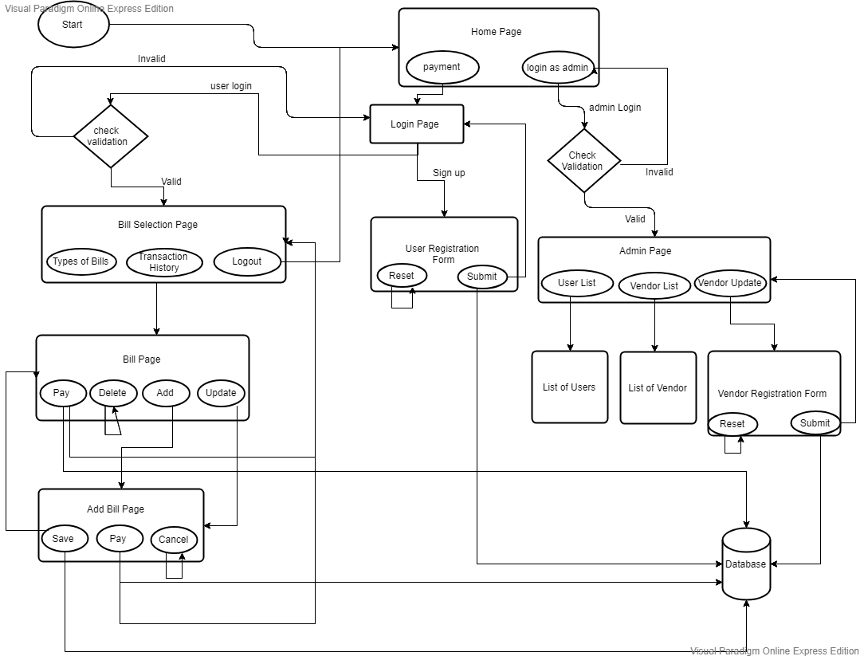

**Overview of Bill Payment System**

**Chapter 3**

3.1 Functional Requirements

The functional requirements are charted for each of the high level requirements called out in the earlier section:

Additionally, the following elements are captured for each business requirement in the table provided below: -

* Req. Type = (F Core Functionality, E Exception, UI User Interface, R Reporting)

** Priority of Requirement = (1=Base Functionality, 2=Advanced Functionality,

3=Additional Opportunities)

** Originator = (Name of the business process of the system/ department or function

name in the customer organization)

The Requirements in this document are prioritized as follows:

3=Additional Opportunities)

** Originator = (Name of the business process of the system/ department or function

name in the customer organization)

The Requirements in this document are prioritized as follows:

|  |  |  |
| --- | --- | --- |
| **Value** | **Rating** | **Description** |
| 1 | Critical | This requirement is critical to the success of the project. The project will not be possible without this requirement. |
| 2 | High | This requirement is high priority, but the project can be implemented at a bare minimum without this requirement. |
| 3 | Medium | This requirement is somewhat important, as it provides some value but the project can proceed without it. |
| 4 | Low | This is a low priority requirement, or a “nice to have” feature, if time and cost allow it. |
| 5 | Future | This requirement is out of scope for this project, and has been included here for a possible future release. |

|  |  |  |  |  |  |  |  |
| --- | --- | --- | --- | --- | --- | --- | --- |
| **Req. #** | **Rationale Categorization** | **Business Requirement** | **Req.**  **Type**  **\*** | **Priority \*\*** | **Originator**  **\*\*\*** | **BR Traced to Business**  **Requirement / Use case ID** | **Remarks** |
| 1.01 | New User  Registration | When the user clicks on the  registration link,  system should re-  direct to registration form and provide two options:  Register as  Customer  Register as Admin | UI | Critical | NA | REQ-1 |  |
| 1.02 | New User  Registration | User to fill the basic attributes:  First Name  Last Name  Age  Gender  Contact Number  Email Address  PAN  Aadhar Number  User Id  Password | UI | Critical | NA | REQ-1 | Please refer  Table 1.0 under References section |
| 1.03 | New User  Registration | Clicking ‘Submit’ button should  validate the  datatype  constraints for each field. | F | Critical | NA | REQ-1 |  |
| 1.04 | New User  Registration | User failing to provide information for the mandatory  fields be presented with an alert  message – ‘Please update the  highlighted  mandatory field(s).’ Also, highlight the missed out field in  red | E | Critical | NA | REQ-1 |  |

|  |  |  |  |  |  |  |  |  |
| --- | --- | --- | --- | --- | --- | --- | --- | --- |
| 1.05 | New User  Registration | Post-successful field validation, save the  information in the database | F | Critical | NA | REQ-1 |  |  |
| 1.06 | New User  Registration | Upon saving the information in the  database, display  the message “New user created successfully” | E | Medium | NA | REQ-1 |  |  |
| 2.01 | User login | A registered user – is able click ‘Login’ link, after keying in ‘UserID’ & ‘Password’ field and get his  credentials  authenticated with the existing database entry. | F | Critical | NA | REQ-2 |  |  |
| 2.02 | User login | If a registered user  – is unable to login and get his  credentials  authenticated, The user is presented  with relevant error messages:  Invalid User ID (or)  Incorrect Password | F | Critical | NA | REQ-2 |  |  |
| 3.01 | Vendor  Registration | Admin clicks on the “Register Vendor” button | F | Critical | NA | REQ-3 |  |  |
| 3.02 | Vendor  Registration | Portal to display a form to enter the  below details:  Name of the  Vendor  Company Reg. No  Vendor Type  Address  Country  State  Email Address  Contact number  Web site  Certificate Issued Date  Certificate Validity date  Year of  Establishment | F | Critical | NA | REQ-3 | Please refer  Table 2.0 under References section | |
| 3.03 | Vendor  Registration | The display form should have buttons to “Register” or  “Reset” the fields | F | Critical | NA | REQ-3 |  | |

|  |  |  |  |  |  |  |  |
| --- | --- | --- | --- | --- | --- | --- | --- |
| 3.04 | Vendor  Registration | Clicking on  Register button should save the details to the  database and  display the  message “Vendor registered successfully” | UI | Critical | NA | REQ-3 |  |
| 3.05 | Vendor  Registration | Clicking “Reset” button should clear  all the fields and allow Admin to enter new details | UI | Critical | NA | REQ-3 |  |
| 4.01 | Vendor update | Admin should also be allowed to  update the  registered vendor details as and when required | UI | Medium | NA | REQ-4 |  |
| 5.01 | Bills Mapping | Customer to be provided with  option to record the type of bills payed regularly:  Electricity  Telephone DTH  Insurance  Tax  Credit Card  Loan account Others | UI | Medium | NA | REQ-5 | Please refer  Table 3.0 under References section |
| 5.02 | Bills Mapping | Based on the type of bill selected,  display a form to procure the  required details and store in the  Database | UI | Medium | NA | REQ-5 |  |
| 5.03 | Bills Mapping | Validate the entered details and display a message “Details saved successfully” | F | Medium | NA | REQ-5 |  |
| 5.04 | Bills Mapping | Provide an option if the user wants to set reminders to pay the bills | F | Medium | NA | REQ-5 |  |
| 5.04 | Bills Mapping | Allow the user to choose the frequency of reminder and verify user contact information is updated | UI | Medium | NA | REQ-5 |  |
| 6.01 | Bill Payment | User clicks on the option to Pay Bills | UI | Critical | NA | REQ-6 |  |

|  |  |  |  |  |  |  |  |
| --- | --- | --- | --- | --- | --- | --- | --- |
| 6.02 | Bill Payment | Portal to display a dropdown button to select the type of  bill to be payed:  Electricity  Telephone DTH  Insurance  Tax  Credit Card  Loan account Others | F | Critical | NA | REQ-6 | Please refer  Table 4.0 under References section |
| 6.03 | Bill Payment | Post the bill type is selected, Portal to verify the  registered/updated information in the  Database and the pending amount to be payed. | F | Critical | NA | REQ-6 |  |
| 6.04 | Bill Payment | If the details not are not available in the database display  form based on the selected bill type  and allow the user to enter the details | F | Critical | NA | REQ-6 |  |
| 6.05 | Bill Payment | User to select the payment method: Credit/Debit Card  Internet Banking  PayTm  Google Pay e-Wallet | UI | Critical | NA | REQ-6 |  |
| 6.06 | Bill Payment | Based on the selected payment type, portal to  display the form to  enter the required details | UI | Critical | NA | REQ-6 |  |
| 6.07 | Bill Payment | Portal to process the payment  through vendor payment gateway | F | Critical | NA | REQ-6 |  |
| 6.08 | Bill Payment | Validate the provided details  against the banks and display a  message “Bill payment  Successful” | F | Critical | NA | REQ-6 |  |
| 6.09 | Bill Payment | If the entered details do not  match display  message “Enter correct details” | F | Critical | NA | REQ-6 |  |
| 7.01 | Help | Allows the user or admin to report technical issues | F | Low | NA | REQ-7 |  |

References

User Table

|  |  |  |  |  |  |
| --- | --- | --- | --- | --- | --- |
| **Field**  **Name** |  | **Field Type** | **Data Type** | **Mandatory** | **Possible Values** |
| First Name |  | Text(50) | Alphabetic | Yes |  |
| Last Name |  | Text(50) | Alphabetic | Yes |  |
| Age |  | Numeric(2) | Numeric | Yes |  |
| Gender |  | Drop Down | NA |  | Male, Female |
| Contact Number |  | Text(10) | Numeric | No |  |
| PAN |  | Text(15) | Alphanumeric | Yes |  |
| Aadhar Number |  | Text(15) | Alphanumeric | Yes |  |
| UserId |  | Text(15) | Alphanumeric | Yes | UserId |
| Password |  | Text(15) | Alphanumeric | Yes | Password |

Vendor Table

|  |  |  |  |  |
| --- | --- | --- | --- | --- |
| **Field Name** | **Field Type** | **Data Type** | **Mandato ry** | **Possibl e**  **Values** |
| Name of the Vendor | Text(50) | Alphabetic | Yes |  |
| Company Reg. No | Text(50) | Alphabetic | Yes |  |
| Vendor Type | Drop Down | NA | Yes |  |
| Address | Drop Down | NA | Yes |  |
| Country | Drop Down | NA | Yes |  |
| State | Drop Down | NA | Yes |  |
| Email Address | Text(15) | Alphanumeric | Yes |  |
| Contact number | Numeric (12) | Numeric | Yes |  |
| Web site | Text(15) | Alphanumeric | Yes |  |
| Certificate  Issued Date | Drop Down | NA | Yes |  |
| Certificate  Validity date | Drop Down | NA | Yes |  |
| Year of | Drop Down | NA | Yes |  |
| Establishment |  |  |  |  |
| Payment  Gateway | Text(15) | Alphanumeric | Yes |  |

Bill Table

|  |  |  |  |
| --- | --- | --- | --- |
| **Column Name** | **Data Type** | **Length** | **Nulls** |
| billId | int | 50 | N |
| amount | float | 10 | N |
| cardNumber | varchar | 15 | N |
| billType | varchar | 50 | N |
| username | varchar | NA | N |
| pan | varchar | NA | N |
| vendorName | varchar | NA | N |
| billStatus | varchar | NA | N |
| paymentThrough | varchar | NA | N |
| cardCVV | varchar | NA | N |
| cardName | varchar | NA | N |
| cardExpiryDate | varchar | NA | N |

CODES REQUIRED FOR FRONTEND(JSP)

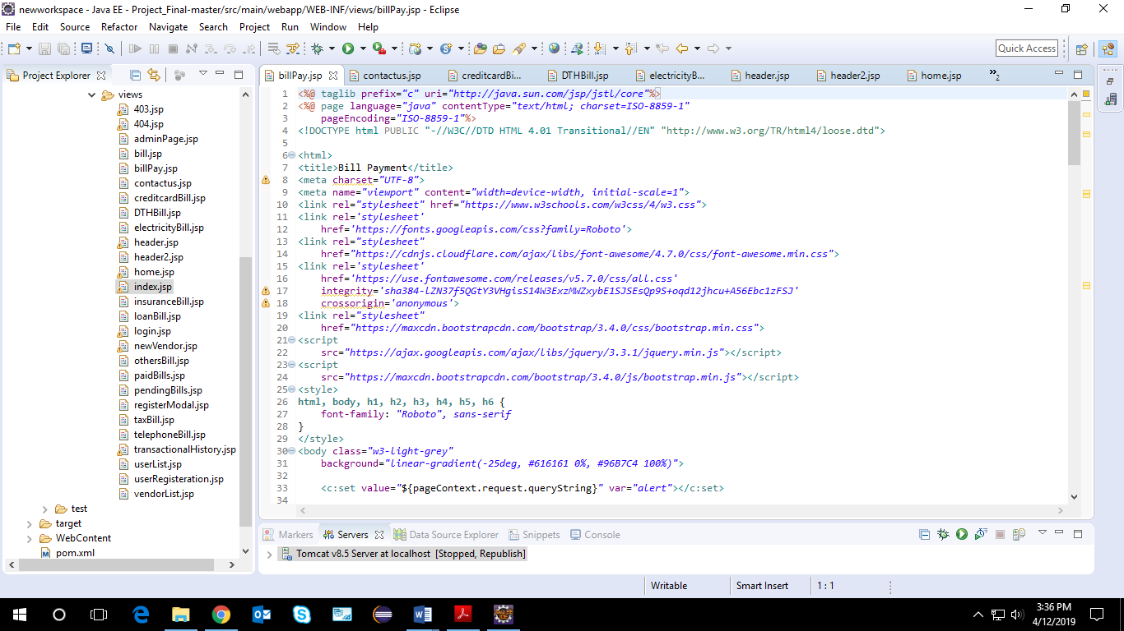

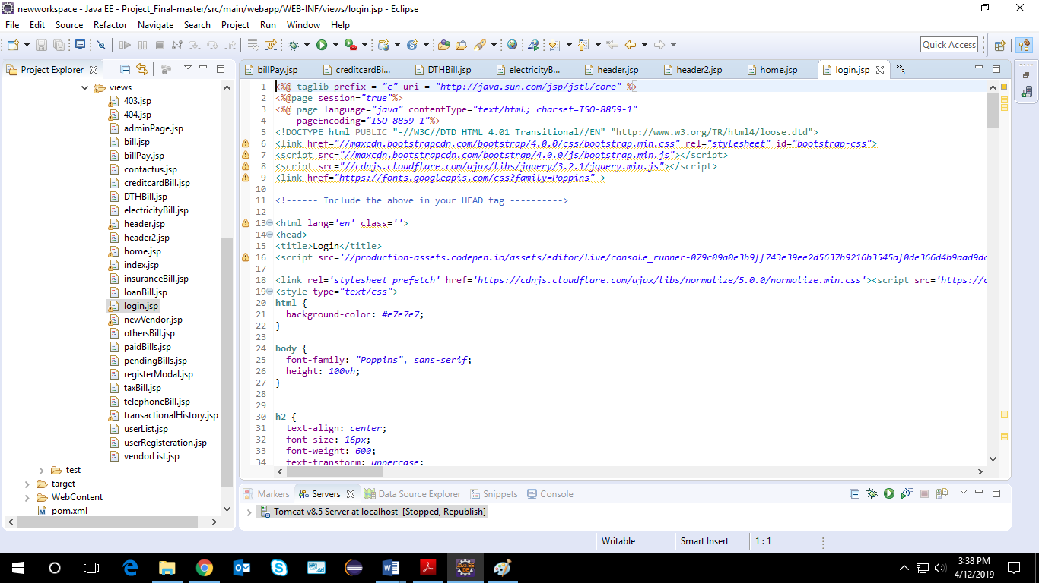

CODES REQUIRED FOR MIDDLEWARE

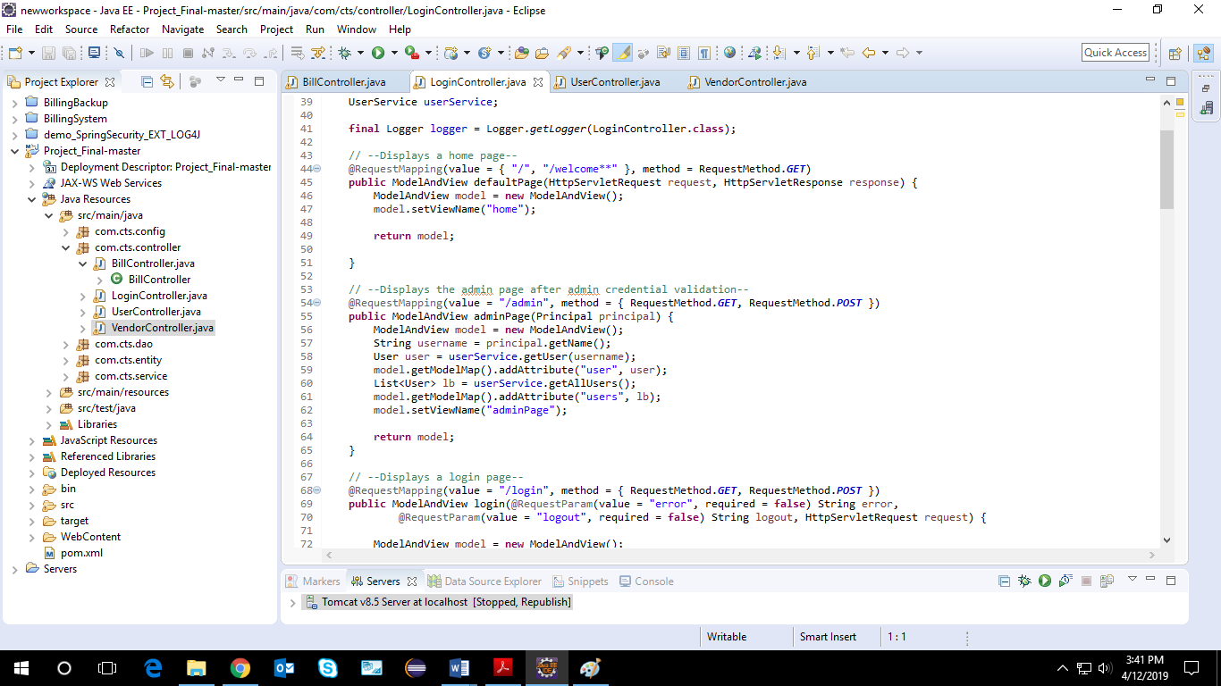

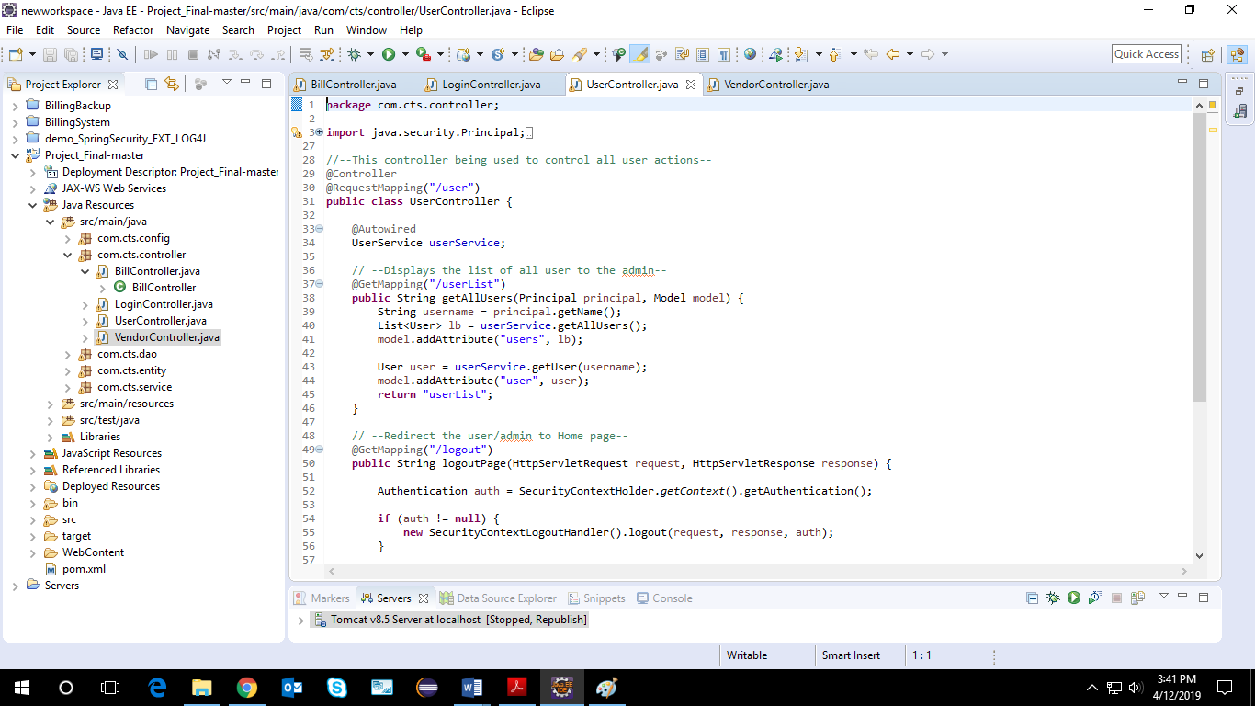

CODES FOR BACKEND

